Ryan R Holmes, Ph.D.

Email: RyanRHolmes10@gmail.com Phone: (816) 726-8624

Degrees
Ph.D. | Engineering, University of Missouri—Kansas City, 2018
M.S. | Civil Engineering, University of Missouri—Kansas City, 2016
B.S. | Civil Engineering, University of Missouri—Kansas City, 2013

Researcher IDs
Scopus Author ID: 55831244200
ORCiD: 0000-0002-3049-7017

Professional Memberships
Environmental and Water Resource Institute (EWRI) 2016 - Ongoing
American Society of Civil Engineers 2016 - Ongoing
American Coal Ash Association 2016 - Ongoing
American Concrete Institute 2015 - Ongoing

Scholarly Contributions
Published Peer Reviewed Journal Articles

Holmes, R., Hart, M. L., and Kevern, J. T. (2017). Removal and Breakthrough of Lead, Cadmium, and Zinc in Permeable Reactive Concrete. Environmental Engineering Science. DOI:10.1089/ees.2017.0160,

Holmes, R., Hart, M. L., & Kevern, J. T. (2017). Enhancing the Ability of Pervious Concrete to Remove Heavy Metals from Stormwater. Journal of Sustainable Water in the Built Environment. DOI: 10.1061/JSWBAY.0000823

Holmes, R., Hart, M. L., & Kevern, J. T. (2016). Heavy Metal Removal Capacity of Individual Components of Permeable Reactive Concrete. Journal of Contaminant Hydrology.
DOI: 10.1016/j.jconhyd.2016.12.005

Holmes, R., Hart, M. L., & Kevern, J. T. (2018). Removal of Arsenic from Synthetic Groundwater Using Sulfur-Enhanced Cement-Based Filter Media. ASCE's Journal of Hazardous, Toxic, and Radioactive Waste.
DOI: 10.1061/(ASCE)HZ.2153-5515.0000440
Holmes, R., Hart, M. L., & Kevern, J. T. (2018). Reuse of Drinking Water Treatment Waste for Remediation of Heavy Metal Contaminated Groundwater. NGWA Groundwater Monitoring & Remediation.
DOI: 10.1111/gwmr.12348

Peer Review Conference Publications
Hart, M. L., Kevern, J. T., Holmes, R., & Silvius, A. A. (2016). Heavy Metals Sorption by Drinking Water Treatment Byproducts in Jar Tests. (pp. 32–41). GeoChicago 2016: Sustainable Waste Management and Remediation, Chicago, IL: ASCE. DOI: 10.1061/9780784480168.004

Holmes, R., Chen, Z., Tripathi, R., Chen, J., Chen, Z., and Tripathi, R. (2013) 1-G Scale Hydraulic Flume-Based Soil-Fluid-Structure Model Testing and Evaluation of Surging and Scouring Effects. (pp. 2394-2409). Structures Congress 2013, Pittsburgh, PA: ASCE. DOI:10.1061/9780784412848.209

Pang, W., Chen, Z., Liu, F., and Holmes, R. (2012) Failure Risk of 230 KV Electricity Transmission Lines in South Carolina under Hurricane Wind Hazards. (pp. 840-850). Advances in Hurricane Engineering, Miami, FL: ASCE. DOI:10.1061/9780784412626.073

Holmes, R., Melander, J. R., Weiler, R. A., Schuman, T. P., Kilway, K. V., and Eick, J. D. Polymerization Stress and the Influence of TOSU Addends on Methacrylate Composites. (pp. 761-762). ASME 2012 Summer Bioengineering Conference, Fajardo, Puerto Rico: ASME. DOI:10.1115/SBC2012-80627

Melander, J. R., Holmes, R., Yao, X., Weiler, R. A., and Eick, J. D. Measuring Strain in Bone Cement with Carbon Nanotubes. (pp. 549-550) ASME 2012 Summer Bioengineering Conference, Fajardo, Puerto Rico: ASME. DOI:10.1115/SBC2012-80620

Scholarships, Grants, and Awards
American Society of Civil Engineers: Freeman Fellowship, 2017 ($6,000)
Third place Awardee at Cuban Infrastructure Scholarship Competition, 2017 ($1,000)
American Coal Ash Association: John H Faber Scholarship, 2016 ($2,500)
School of Graduate Studies Research and Travel Grants, 2018, 2017, 2016 ($9,000)

Teaching

Course Taught at the University of Missouri –Kansas City
Mech Eng. 285, Engineering Dynamics, 3 credits (Summer Semester)

Teaching Assistant
Civil Eng. 318 GIS for Engineers, 3 credits (Spring 2016 & 2017)
Civil Eng. 335 Soil Mechanics, 3 credits (Spring 2016 & 2017)
Mech Eng. 220 Electric Circuits, 3 credits (Spring 2018)

Service
RooBuilders, bridge building competition. Fall ‘13 – Fall ‘18
Summer STEM Outreach, mixed concrete samples, broke bridges, and talked about STEM with high school students from underrepresented minority groups. Summer ‘17 & ‘18
Engineering Day, Fall 2018, demonstration for high school freshmen mixing concrete and talking about potential STEM careers

Peer Reviewer
Journal of Materials in Civil Engineering (2)
Environmental Engineering and Science (1)
Construction and Building Materials (1)

Research Statement for Ryan Holmes
Interdisciplinary research is at the core of my degree and research interests. Fundamentally I am a research-engineer, meaning I desire to discover new features within science and then explore potential applications for improving human life and the environment. My research interests lie in advancing novel materials for use in environmental remediation, developing alternative energy from cement wastes, enhancing sustainable geopolymer systems, modeling chemistry-coupled fluid dynamics for use in the above systems, and investigating polymers for integrated “green” infrastructure. My long-term goals are to become an established researcher producing patentable technologies targeting the cradle-to-cradle use of engineered materials and to develop the tools necessary for engineers to apply those technologies.
Historically, scientists have developed techniques and technologies to explore specific silos of science, such as inorganic chemistry or civil engineering materials. In demarcating topics, the overlap between fields has been largely ignored. The deconvolution and clarification of overlapping fields is exciting to me because each gap between disciplines holds potential for new interpretations of previous findings. For example, delayed ettringite in cement is considered deleterious for construction, but during my dissertation I established ettringite in cement-based filters enhances removal of specific contaminants. This non-traditional, even contrary application of basic science required bridging multiple fields from infrastructure to chemistry to geology to answer a new question. Similarly, I was awarded the John Faber Scholarship from the American Coal Ash Association for work in beneficiating off-spec fly ash to remove heavy metals in aqueous systems.
I enjoy the synthesis of ideas and desire to collaborate with the highly respected faculty members at the University of Minnesota to advance engineered materials for water remediation as outlined by Figure 1. My short-term goals are to further explore use of cement-based filter media (CBFM) for treatment of low-level radioactive contaminants and estrogenic personal care products (PCPs) in water. Collaboration opportunities with Drs. Novac, Castrillón, Gulliver, and Voller will likely produce papers of exceptional quality advancing research in bio-facilitated remediation, graphene oxide-portland cement hybridization, CBFM design specifications, and modeling of mass transport in specific phase change systems used for removal within CBFM, respectively. University of Minnesota also offers the Radiation Safety Training program and permits to allow for research in radioactive remediation as well as the Minnesota Tribal-State Relations Training program to help interface with Navajo and Rosebud Sioux Nations when exploring applications of CBFM on high-priority radioactive sites.
In the long-term, as CBFM become more widely accepted, sensor and sensor array development will become increasingly important. Therefore, working with Dr. Linderman’s experience in wireless smart sensors for structural health will be invaluable. To power those systems remotely, local energy or remote sensors could be derived from the contaminants or removal mechanisms occurring in the CBFM. To take advantage of this, collaboration with the chemistry department in the area of polymers and electrolytic systems will be vital. To connect these areas, Dr. Hozalski’s experience with energy derived from biofilms and surface reactions may help to advance the removal mechanisms while also generating energy for the sensors. Dr. Le’s experience in durability of quasibrittle materials and graphene nanoplatlets will help intercept potential problems with sensor implementation from a mechanical standpoint. Lastly, Dr. Gonella may provide key insights on how to integrate some of the sensors with regard to dynamic tuning.

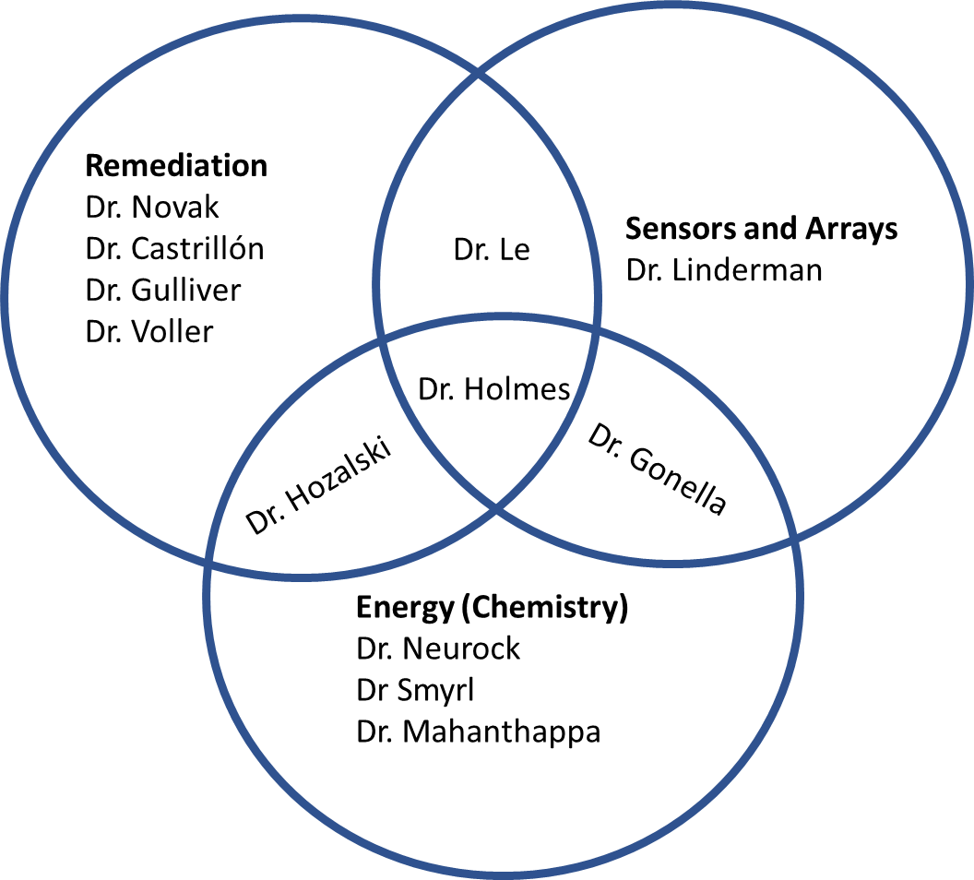
Figure 1. Areas of interest, potential collaboration opportunities, and future research foci

This cross-communication between research silos coupled with industry support is essential to achieve success when applying for Grand Challenges or NSF Big Ideas. Accordingly, I have worked with a local power supply company to provide a cost-effective and innovative solution to remediate contaminated site water. The groundwork for cement-based filters was laid during my doctoral studies but the implications have vast long-term potential as clean water and remediation of anthropogenic or lithographic contaminants will be topics of concern for the foreseeable future.
I am an especially creative researcher capable of performing at the highest levels of academic work with publications in engineering and environmental science. The CEGE department has the expertise, materials, and equipment to produce excellent research and together with my work, we could make significant contributions to engineering and science.

Teaching Statement for Ryan Holmes
My teaching philosophy is to encourage students to work with excellence in their academic pursuits to prepare them for a successful engineering career. I believe there are no shortcuts to learning, so as a mentor I will expect a lot from my students with the understanding that students will rise to the challenge. Throughout my experience as a student, teacher’s assistant, and instructor I have had excellent role models and mentors who have taught and demonstrated the effectiveness of having high standards and strict deadlines. They have also established the necessity for teamwork regardless of team composition. Upon expressing my desire to pursue an academic career, my mentors provided increasingly more difficult opportunities for me to practice and develop my own teaching style. Ultimately this allowed me to be the primary instructor for Engineering Dynamics during the summer of 2018.
I enjoy teaching students new concepts and especially love the moments when the students grasp a challenging topic. I desire to give students opportunities to grow by challenging their analytical skills and developing a habit of critical self and peer assessment. I believe a critical component in teaching such skills is reviewing students’ assignments for content and form because engineers are required to show and tell their results. I also encourage students to rely on each other through cooperative learning. Mimicking my undergraduate experience, a student during class may be asked to work a problem on the board. The class is then asked to support that student by calculating numeric values, with at least two people having the same answer. This promotes accountability and teambuilding. Students are also encouraged through ample homework to develop strong time management skills to meet clear and strict deadlines. I believe it is the student’s responsibility to apply themselves to studying, asking questions, and seeking help from myself and their peers. To ensure students have opportunities for questions, I provide a 1- to 2-hour, student-driven study session to work problems on the board before each exam, in addition to office hours each week. Some other tools I utilize include regular homework assignments to grapple with the content, pop quizzes to confirm home-based-grappling is occurring, and milestone tests to prove to the students that they are advancing. I also support giving students room for mistakes by providing mechanisms for course correction along the learning path. One example is the offering of bonus homework centered around application of the material. Bonuses require writing, illustrating, and answering one self-originating, real-world problem from each of the chapters with the requirement that no problems or examples from the text can be used. This achieves both goals of grappling with the content and reviewing the material.
In recent years inclusivity and diversity have become a central focus of education in the higher and lower education systems. I believe respect of student identity is important for communicating with students, and it is a skill I have been developing through volunteering at STEM activities with middle and high school students from underprivileged communities. Through these opportunities, I have observed that student’s race, gender, class, and background have no role in determining expectations of the student. To do so would deny a student the opportunity to grow and would show favoritism. To remedy any lacking knowledge from previous classes, I give special attention to fundamentals and provide similar examples through the semester to tie concepts together so that all students have equal opportunity to learn. As stated earlier, hard work by the student is essential for successful education, but it should be coupled with smart-work which comes from the humility to ask questions of peers and teachers. Any student who works hard and is willing to seek and accept help from others will be successful in my class.

